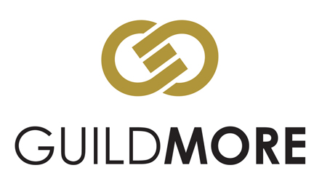
Land Manager

Location: Bromley, Kent.
Reporting to: Head of Operations
Contract: Permanent

We have an opportunity for an experienced Land Manager to oversee site acquisition within the M25 and Home Counties within our mixed use development and regeneration business based in Bromley, Kent. Buying levels can be anywhere from £1m - £30m, with a GDV of £3m - £80m. The focus will be around residential led mixed use sites which could be land with or without planning permission.
Our company is part of a group turning over £100m per year with over 2500 employees.
We work with multiple public and private sector partners, including Housing Associations, Local Authorities and numerous charity organisations throughout London and the South East.

Roles and Responsibilities

Liaising with an extensive network of local agents, land traders and other stakeholders to:
- Identify potential developments followed by the co-ordination of the appraisal in order to generate a land offer for submission.
- Negotiate with vendors and other parties to secure the site including where necessary OJEU type presentations.
- Liaison with all relevant external bodies, consultants and architects (interrogation of architectural designs) and internal departments.
- Research local property market for comparable sales figures and review technical reports associated with sites and identification of key information pertinent to pricing.
- Selection and liaison with solicitors and other external parties to effect the legal acquisition.
- Subsequent work will be associated with the acquisition process, from purchase and planning process in order to achieve a site start through to pre-construction.
- Management responsibility for a land buyer and graduate staff.

Professional Competencies Required

- Experience of negotiating land transactions.
- Knowledge of land, planning and construction in the residential sector.
- Knowledge of basic legal processes associated with conveyancing, viability, and town planning.
- Identification of land opportunities through local plans and agents.
- Previous experience of working within the industry and sourcing land / development opportunities.
- Ability to work autonomously and independently from the rest of the team.
- You will be organised, confident and possess excellent communication skills.
- Degree or equivalent preferred.

Personal Competencies Required

- A strong network of contacts in the land agency market.
- Determined and ambitious.
- Strong communication and negotiations skills.
- Possess an ability to liaise confidently at all levels.
- Excellent organisational, prioritisation and time management skills.
- Ability to manage and motivate junior colleagues.

